Call for Proposals
for the
50th Annual Conference
of the
International Society of
Educational Planning

CONFERENCE THEME:
Change & Continuity in Educational Planning: Past, Present, & Future

Washington, DC
October 13-16, 2020

Embassy Suites by Hilton, Washington DC Georgetown

1250 22nd Street NW, Washington, DC 20037

TEL: +1-202-857-3388

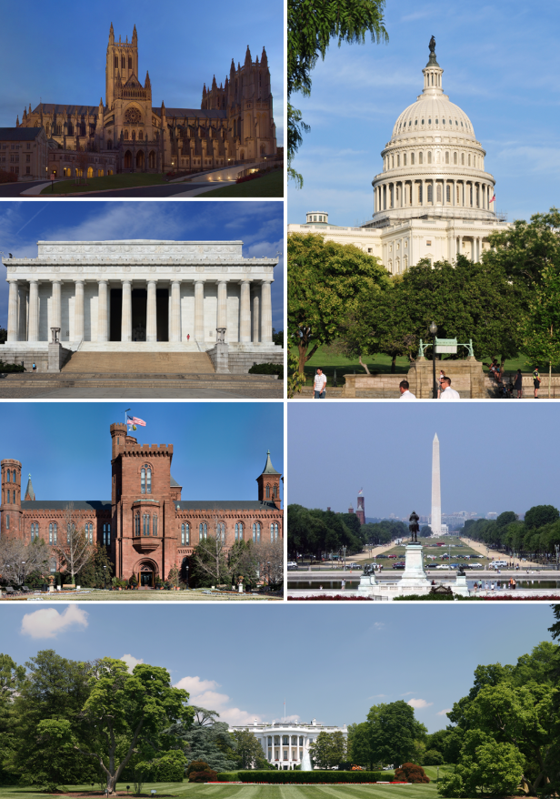

What is ISEP?
The International Society for Educational Planning (ISEP) was founded on December 10, 1970, in Washington, D.C. Over 50 local, state, national, and international planners attended the first organizational meeting.

Over time, the dynamics of educational reform throughout the world have demonstrated that there is need for a professional organization with a primary focus on educational planning and policy.

ISEP includes members from more than 20 nations, many backgrounds, and many levels of professional responsibility and interests. But we are small enough to make lifelong contacts, networks, and friendships. The two major activities of ISEP are:
- Annual Conference. Usually two conferences in the US and then one in another nation. Past conferences have been held in the United States, Canada, Turkey, North Cyprus, Hungary, Italy, Trinidad, and Portugal.
- Educational Planning, the official journal of ISEP, is a peer-reviewed, professional journal dedicated to all aspects of educational planning and leadership. For information regarding the journal, please click on the following link:
http://isep.info/submission-of-manuscripts for submission information.

For access to past journals clink on the following link: http://isep.info/educational-planning-journal/journal-archive.

WHO ATTENDS THE ISEP CONFERENCES?

- Higher Education Faculty & Administrators
- Educational Planners
- Policy Makers
- Researchers
- Leaders Involved in Educational Planning
- Educational & Government Consultants

- School Teachers & Administrators
- Local Government Leaders
- Graduate Students
- Architects

2020 CONFERENCE PLANNING TEAM
- Abebayehu Tekleselassie, PhD; ISEP President; The George Washington University silassie@gwu.edu
- Angel Ford, EdD; ISEP Vice-President; Addis Ababa University and Liberty University angela.ford@fulbrightmail.org
- Peter Litchka, EdD; ISEP Past President; Loyola University Maryland prlitchka@loyola.edu
- Jodie L. Brinkmann, EdD; ISEP Treasurer, Virginia Tech University, Virginia jlbrinkmann2@gmail.com
- Carol Cash, EdD; ISEP Secretary; Virginia Tech University ccash48@vt.edu
- Adam Nir, PhD; The Hebrew University of Jerusalem adam.nir@mail.huji.ac.il
- Walter Polka, PhD; Niagra University wpolka@niagara.edu
- Ronit Bogler, PhD; The Open University of Israel ronitbo@openu.ac.il
- Linda Lemasters, EdD; Professor Emeritus, The George Washington University lindal@gwu.edu
- Glenn Koonce, EdD; Regent University glenkoo@regent.edu
- Glen Earthman, PhD; Virginia Tech University earthman@vt.edu
- TC Chan, Kennesaw State University tchan@kennesaw.edu
- Robert Johnson, PhD; Professor Emeritus, St. Cloud State University robjohn@stcloudstate.edu

PRESENTATIONS and PROPOSALS
The planning committee is interested in obtaining original manuscripts, papers and other presentations dealing directly with the general theme of the conference and that are aligned to the focus sessions listed below.
Conference Theme:
Change & Continuity in Educational Planning: Past, Present, & Future

Thematic Session 1– Educational Planning – People
Session Sponsors: Drs. Polka and Brinkman
This session will focus on the conceptualization of educational planning as a discipline, examining salient Ideas about leadership approaches, professional development, and organizational assessments of people in school settings that have informed the planning field globally over the years. Consistent with ISEP’s 50th anniversary to address change and continuity in educational planning, session presenters will explore topics related to classical and contemporary approaches to human resource planning with the focus on: leadership approaches, professional development, organizational assessments, and other people oriented perspectives, debates, and controversies including conflicting theories that have shaped planning for the development and evaluation of educational leaders throughout the world.

Possible topics for session presenters include (but are not limited) to the following:
- The changing nature of educational leadership and professional development
- The link between organizational outcomes in education (such as student outcomes) and effective human resource practices.
- Strategic planning as a professional development process.
- Key partners/stakeholders in human resource management.
- Common elements/frameworks of “best-practices” in planning for effective leadership, professional development, and organization assessment.
- Systems thinking and strategic planning in human resource practices.
- Strategic planning and organizational assessments and accountability.
- Planning for personal, professional, and organizational change in education.
- International/comparative experiences and studies.

Potential Themes and Keywords: leadership approaches; coping with changes; strategic human resource planning theory; human resources plan implementation; planning partners; ‘high-touch’ planning for educational change/reform.

Thematic Session 2 – Educational Planning – Things
Session Sponsors: Drs. Cash and Koonce
This session will focus on the conceptualization of educational planning as a discipline, examining salient Ideas that have informed the built facility, technology, and furnishings in support of the school community globally over the years. Consistent with ISEP’s 50th anniversary to address change and continuity in educational planning, session presenters will explore topics related to classical and contemporary approaches to facility design and redesign with the focus on 21st-century skills development, instructional support, student responses to the environment, and other built facility oriented perspectives, debates, and controversies including conflicting theories that have shaped the field of school design throughout the world.

Possible topics for session presenters include (but is not limited) to the following:
- The changing nature of school design research in education
- The link between the built facility and student and faculty performance/attitudes
- A process for designing the built facility – purpose leads to form
- The relationship between classroom furnishings and instructional practices
- The challenges of historical buildings (heritage sites) in access, design, and function
- How educational facilities adjust to contemporary pedagogical demands, practical uses, or economic constraints
- How schools can adapt to an increasing and changing population, as well as, social, curricular, or pedagogical developments
- How historical legacy and memory can be, or has been, preserved through basic design and instructional changes
- Case studies from different geographical areas, providing a basis for reflecting on the significance of educational facilities for education within an international framework
- Architectural solutions to design adjustments for current student needs
- Identifying spatial, functional, and technological modifications and guidelines to cope with educational change and contemporary challenges

Potential Themes and Keywords: architecture; design changes; renovation and redesign; planning for a new school; planning partners for shared school use; furnishings and instruction for the 21st century; and retaining the legacy while recharging the function.

Thematic Session 3 – Educational Planning – Ideas
Session Sponsors: Drs. Ford & Tekleselassie
This session will focus on the conceptualization of educational planning as a discipline, examining salient Ideas that have informed the field globally over the years. Consistent with ISEP’s 50th anniversary to address change and continuity in educational planning, session presenters will explore topics related to classical and contemporary approaches to planning, where the focus includes ideas, perspectives, theorists, theories, debates and controversies that have shaped the field throughout the world.

Possible topics for session presenters include (but are not limited) to the following:
- The changing nature of strategic planning research in education
- The link between strategic planning and organizational outcomes in education (such as student outcomes)
- Strategic planning as a strategic development process
- Key partners/stakeholders in strategic planning
- Common elements/frameworks of “best-laid plans”
- The link between strategic plans and site-based plans in education
- Systems thinking and strategic planning
- Why do strategic plans fail?
- Strategic planning and accountability
- Strategic planning as a catalyst for organizational change in education
- What has been learned about planning from international/comparative experiences and studies.
- Strategic planning and social change, national and global perspectives

Potential Themes and Keywords: strategic planning theory; strategic plan outcomes; plan implementation; site-based versus strategic planning; strategic priorities; planning partners; strategic planning and educational change/reform.
PROPOSAL GUIDELINES and SUBMISSION INFORMATION
ISEP accepts presentation proposals on a rolling basis and sends notifications within two-weeks of submission. Presentations should be designed for a 20-minute time slot followed by a short time for questions from the audience. Papers derived from the presentations can be submitted for peer-review for possible inclusion in the Educational Planning Journal.

Please provide the following information in your proposal submission and email documents to angela.ford@fulbrightmail.org

Or visit our website and use the online form located at: http://isep.info/2020-conference-call-for-proposals

- Title of Presentation
- Focus Session Number (select from the list above)*
- Presenter’s Name
- Email address
- Current Position
- Institution
- Additional Presenter’s Name, Email address, Current Position and Institution
- Presentation Description (350-500 words)
  - Objectives for the proposal
  - Summary of content

Important Dates and Deadlines for Proposal Submissions and Registration
- June 1, 2020: Deadline for Early Bird Submission of Proposals.
- July 1, 2020: Deadline for Submission of Proposals.
- July 5, 2020: Final notification of acceptance of proposals will occur via email.
  - All presenters listed in the accepted proposals must pay the full registration fee, even if they attend the conference only on the day of their presentation.
- September 1, 2020: Registration Fee: The full registration fee must be received by the
International Society for Educational Planning (ISEP) no later than September 1, 2020 in order for the presentation and the presenter to be listed on the conference program. Any author identified in the presentation, but not officially registered for the conference by the due date, will not be listed in the official program of the conference.

GLEN EARTHMAN OUTSTANDING DISSERTATION AWARD

The International Society for Educational Planning recognizes outstanding dissertations related to all aspects of educational planning. The Society will consider dissertations that have been completed between 2016 and 2019 that resulted in the award of a terminal degree. We encourage the submission of dissertations on any aspect of educational planning.

Dissertations that deal with planning and program implementation on the international, state/provincial, regional, local and individual school or building levels are welcomed. Individuals who have recently been conferred their doctoral degree may individually submit their dissertation for consideration. The chairperson of the dissertation committee or any member of the committee also may recommend a dissertation for consideration.

Individuals who are chosen for recognition will be asked to make a presentation of their findings at the annual meeting. In addition, these individuals will be asked to submit a manuscript to the Society’s journal, Educational Planning. An unbound copy of the dissertation and an electronic version of the dissertation should be sent/emailed to facilitate distribution to the committee for a double-blind review. Complete identification including name, address, phone number, and email address should accompany the dissertation on a separate page. Deadline for submission is June 1, 2020. Individuals to be recognized will be notified no later than July 15, 2020. Interested candidates/nominees are encouraged to submit abstracts to:
Robert C. Johnson, Ph.D.
Professor, Department of Ethnic Studies
St. Cloud State University, St. Cloud, MN 56301 320-308-2553, Office;
320-308-2554, Fax
robjohn@stcloudstate.edu

CONFERENCE VENUE

Embassy Suites by Hilton, Washington DC Georgetown

1250 22nd Street NW, Washington, DC 20037

TEL: +1-202-857-3388

Here’s a link to the hotel website.
washingtondc.embassysuites.com

Embassy Suites by Hilton, Washington D.C. is a renovated hotel located between Dupont Circle and Georgetown. It’s only 4 blocks from the D.C. Metro and has a number of restaurants, shops and attractions with walking distance.

All of the rooms are suites and stays include made-to-order breakfast and complimentary evening reception. There is a restaurant on site as well as a fitness center, indoor pool and whirlpool.

Here is a great link to see pictures of the many events that can be enjoyed while staying in the Washington DC area. https://destinationdc.photoshelter.com/galleries/C00004TQwCsxUZY4/Media-Gallery

